Experiment No: 03
Experiment Name:
i. Write an assembly language program to divide two numbers using EMU8086.
ii. Write an assembly language program to multiply two numbers using EMU8086.

Theory: EMU8086 assembly performs multiplication and division using dedicated arithmetic instructions with DOS interrupts. For multiplication, load the first number into AL and the second into BL, then execute MUL BL to store the result in AX. Add 48 to AL to convert the product into ASCII, move it to DL, set AH to 2, and call INT 21H to display it. For division, load the dividend into AL and the divisor into BL, then execute DIV BL to place the quotient in AL and the remainder in AH. Transfer the quotient and remainder into registers like CL and CH to preserve them for individual output. Display the quotient first, output ASCII 10 and 13 for a new line, then display the remainder using AH = 2. Finally, load 4CH into AH and call INT 21H to terminate the program and return control to DOS.

Code & Output:
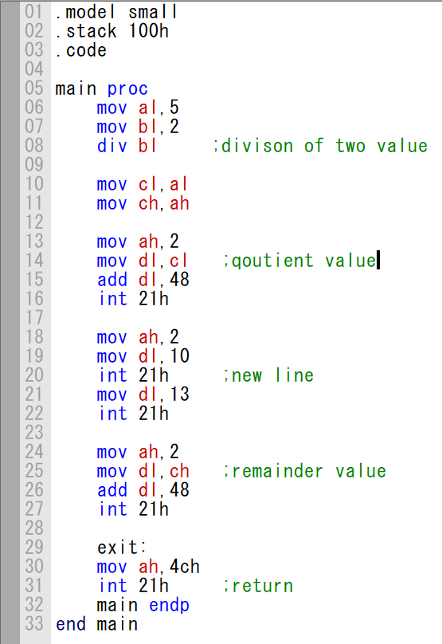
i) Code of division of two numbers:

B0 05 B3 02 F6 F3 8A C8 8A EC B4 02 8A D1 80 C2 30 CD 21 FF FF CF B4 02 B2 0A CD 21 FF FF CF B2 0D CD 21 FF FF CF B4 02 8A D5 80 C2 30 CD 21 FF FF CF B4 4C CD 21 FF FF
Machine Code:

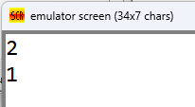
Output:
Output

ii) Code for multiply two numbers:
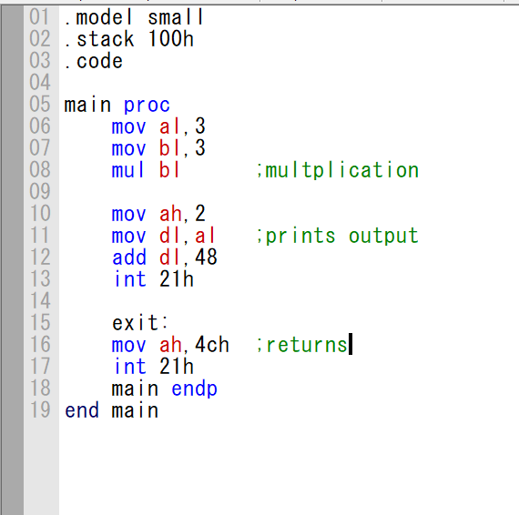

B0 03 B3 03 F6 E3 B4 02 8A D0 80 C2 30 CD 21 FF FF CF B4 4C CD 21 FF FF CF
Machine Code:

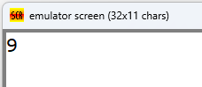
Output:
Output

Conclusion:
The program was executed successfully in the EMU8086 environment, and no errors were found. We successfully learned two arithmetic operation multiplication and division of two numbers(single digit) in assembly language.

